**Detection of VOCs in Enclosed Space Using a Sensor Array**

Aditya Jadhav1, Sujata Patil2, Tejas Jadhav3,Saurabh Hodlurkar4

*Department of E&TC, SKNCOE, SPPU, Pune.*

[*1adityajadhav251102@gmail.com,*](mailto:adityajadhav251102@gmail.com)[*2sujata.patil_skncoe@sinhgad.edu,*](mailto:sujata.patil_skncoe@sinhgad.edu)

[*3jadhavtejas1975@gmail.com*](mailto:jadhavtejas1975@gmail.com)*,*[*4saurabhhodlurkar@gmail.com*](mailto:saurabhhodlurkar@gmail.com)

***Abstract:*** **In an era where rapid industrialization and urbanization continue to shape our environment, ensuring the safety and well-being of individuals in enclosed spaces is of paramount importance. One of the key challenges in this endeavor is the detection of toxic gases and volatile organic compounds (VOCs) that can pose severe health risks if left undetected. So, the primary motive of this model is to design and implement a sensor array system comprising five specialized sensors which are capable detecting a wide range of toxic gases. Employing Raspberry Pi and Arduino platforms for simultaneous data acquisition, the project sought to improve accuracy and real-time monitoring. The system's versatility extended to the detection of volatile organic compounds, with applications spanning industrial, residential, and laboratory settings. Calibration procedures were rigorously undertaken to enhance measurement reliability. The key results of this endeavor encompassed the successful development and calibration of the sensor array, culminating in a comprehensive solution for toxic gas detection in enclosed spaces. Ultimately, this project contributes significantly to safety and environmental well-being.**

**Keywords** —  **Raspberry Pi, Real Time, Safety, Toxic Gases, VOCs.**

I. INTRODUCTION

In today's rapidly evolving world, the need for advanced technologies to ensure environmental safety and human well-being is more significant than ever before. The precise detection of toxic gases and volatile organic compounds (VOCs) in enclosed areas is one of the most important components of protecting lives and protecting the environment. These gases, often colourless and odourless, are extremely dangerous to human health. By developing a sensor array system, this proposed model aims to address this important issue.Traditional gas detection techniques often rely on single sensors, each of which is designed to detect a particular gas. However, these single-sensor systems do have limits, though, as they might not offer a thorough evaluation of the air quality inside a closed environment. The proposed model seeks to overcome these limitations by developing a sensor array system that can simultaneously monitor multiple toxic gases and VOCs.

This project recognizes these limitations and endeavors to address the complex nature of indoor air quality by employing an innovative sensor array system. The sensor array is designed to simultaneously monitor a range of toxic gases and VOCs, thus providing a more comprehensive assessment of the indoor environment. Such an integrated approach enables not only the detection of multiple contaminants but also the quantification of their concentrations, which is invaluable for assessing health risks and taking timely corrective actions.The primary objective of this model is to use a sensor array system to find volatile organic chemicals that are present in enclosed spaces. This application covers a wide range of situations where the presence of dangerous gases could endanger people's health and safety, such as industrial facilities, laboratories, residential areas, and more.

II. LITERATURE SURVEY

A. Holovatyy, V. Teslyuk, M. Lobur, S. Pobereyko and Y. Sokolovsky, "Development of Arduino-Based Embedded System for Detection of Toxic Gases in Air," 2018 IEEE 13th International Scientific and Technical Conference on Computer Sciences and Information Technologies (CSIT): In the paper, the toxic gases detection system in the air environment has been developed. It monitors in real time a concentration of toxic gases and vapors in air. When toxic gases are absence or their concentration is permissible, the system is in the normal mode (monitoring mode). When the maximum permissible norm of toxic gases is exceeded, the system changes its state into alarm mode. In the alarm mode, it switch on the buzzer, the red LED, outputs an alarm message to the LCD module and PC via the serial interface, and also sends SMS to the mobile device via a GSM module.[1]

M. Jualayba, K. Regio, H. Quiozon And A. Destreza, "Hazardous Gas Detection and Notification System," 2018 IEEE 10th International Conference on Humanoid, Nanotechnology, Information Technology, Communication and Control, Environment and Management (HNICEM): Hazardous gases like propane and methane are combustible and could cause explosion if confined in a close room. The study described in this paper comprises a system that involves detection and notification of hazardous gases present in an area. The system has three sensors; hydrogen sensor, Liquefied Petroleum Gas (LPG) sensor, and methane sensor that serve as switches with different set-points. Every level of gas detected is send to the Arduino that serves as the controller which analyze the level of gas present. [2]

“Detection of volatile organic compounds using a commercial gas sensor embedded in a mobile robot," by G. A. García-Rodriguez, IEEE International Conference on Engineering Veracruz (ICEV), Boca del Rio, Mexico, 2021: This paper introduces an innovative unmanned mobile device designed for the detection of volatile organic compound (VOC) leaks, emphasizing the potential impact of these compounds on agriculture, blood, and human health. The system comprises an emitter and a receiver, with the emitter featuring two embedded systems within an 8-bit microcontroller. One system governs the robot's control and decision-making abilities, equipped with proximity and line-following sensors, while the second system monitors VOC levels using commercial gas sensors with a detection range of 10 to 1000 parts per million (ppm). [3]

“Very volatile organic compounds: an understudied class of indoor air pollutants” by T. Salthammer: Very volatile organic compounds (VVOCs), as categorized by the WHO, are an important subgroup of indoor pollutants and cover a wide spectrum of chemical substances. Some VVOCs are components of products commonly used indoors, some result from chemical reactions and some are reactive precursors of secondary products. Nevertheless, there is still no clear and internationally accepted definition of VVOCs. Current approaches are based on the boiling point, and the saturation vapor pressure or refer to analytical procedures.[4]

III.METHODOLOGY

* 1. *Block Diagram*

The sensor array consists of an advanced toxic gas detection system featuring a sensor array comprising five specialized sensors: ZMOD4510AI1R[5], SCD40-D-R1[6], MQ136[7], MS-1100[8], and CO Sensor Module ZE07-CO[9], all meticulously selected to detect a wide spectrum of toxic gases and volatile organic compounds (VOCs). The central processing unit and control hub of this advanced system is the Raspberry Pi, which orchestrates the seamless integration and operation of the sensor array. In real-time, the Raspberry Pi collects precise numerical data indicative of gas concentrations, providing invaluable insights into the environmental conditions. This data is efficiently channeled into a dedicated storage system, facilitating historical record-keeping and in-depth analysis. This invaluable data is efficiently channeled into a dedicated data storage system, facilitating historical record-keeping and in-depth analysis

Beyond immediate monitoring and alerting capabilities in environments prone to toxic gases, the comprehensive nature of this system empowers long-term data insights. The integration of advanced sensors with the Raspberry Pi not only ensures real-time safety but also facilitates informed decision-making through historical data analysis. This novel approach contributes to enhancing safety measures and promoting environmental well-being in diverse settings.

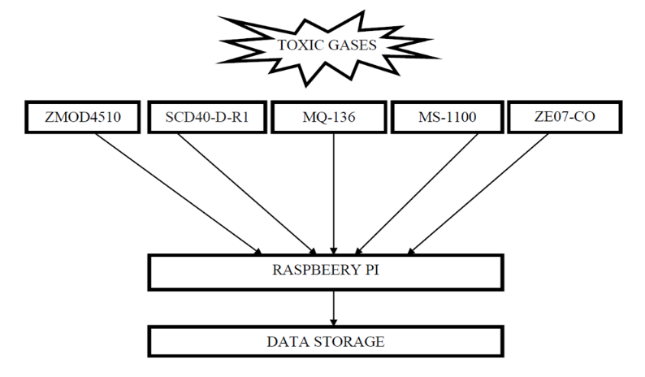

Fig. 1 Block diagram of sensor array system for detection of toxic gases.

* 1. *Flow Chart*

1. Selection of Sensors: Identify and select five specialized sensors suitable for detecting a range of toxic gases and volatile organic compounds (VOCs). Ensure compatibility with the Raspberry Pi and Arduino platforms.

2. Hardware Setup: Connect the selected sensors to both Raspberry Pi and Arduino. Establish proper wiring and connections to ensure reliable data acquisition.

3. Programming Raspberry Pi: Develop code for Raspberry Pi to orchestrate the data acquisition process. This includes constant collection of real-time data from the sensor array, obtaining precise numerical values indicative of gas concentrations.

4. Integration of Sensor Array: Seamlessly integrate the sensor array system with the Raspberry Pi and Arduino, ensuring effective communication and synchronization between the components.

5. Data Acquisition and Storage: Implement the code to continuously collect data from the sensor array in real-time. Design a mechanism to efficiently channel this data into a dedicated storage system, enabling historical record-keeping.

6. Calibration Process: Develop a calibration procedure for each sensor to account for various concentrations of acetaldehyde, NO, and CO. This involves exposing the sensors to known concentrations of gases and adjusting the sensor readings accordingly.

7. Testing and Validation: Conduct thorough testing of the integrated system in a controlled environment to validate its functionality. Ensure that the sensor array accurately detects and responds to different concentrations of toxic gases.

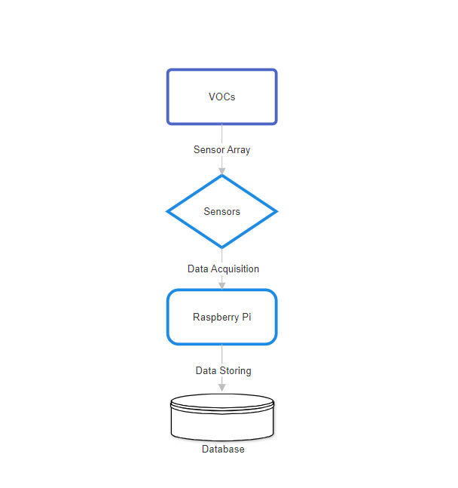

Fig. 2 Flow Chart of sensor array system for detection of toxic gases.

IV. Result and discussion

The results obtained after completing the testing that involved injecting precise concentrations of benzene, toluene, and formaldehyde into the enclosed tin, the sensor responses were meticulously analyzed. The graphical representation of the data revealed distinct patterns and notable spikes corresponding to different gas concentrations. These spikes in the graph are indicative of the sensors' heightened reactivity and responsiveness to the injected gases. For benzene, the graph exhibited discernible spikes in sensor output at each concentration level (1ml, 3ml, 6ml, and 9ml). These spikes, often characterized by elevated sensor readings, signify the sensor's acute sensitivity to increasing concentrations of benzene. The trend was consistent, demonstrating a proportional relationship between the injected benzene concentration and the sensor's response. Similar patterns were observed for toluene and formaldehyde. The graph displayed conspicuous spikes corresponding to each concentration level, illustrating the sensors' ability to detect and react to varying concentrations of these gases. The spikes observed in the graph reflect the dynamic nature of sensor reactions, emphasizing their capacity to discern subtle changes in gas concentration.

These results are integral to understanding the sensors' performance across a spectrum of concentrations, providing valuable insights into their sensitivity and selectivity. The spikes in the graph serve as visual markers, highlighting the precise moments when the sensors register the presence of specific gases. This nuanced analysis contributes to the ongoing refinement of gas detection mechanisms, ensuring the reliability and accuracy of sensor responses in real-world applications.

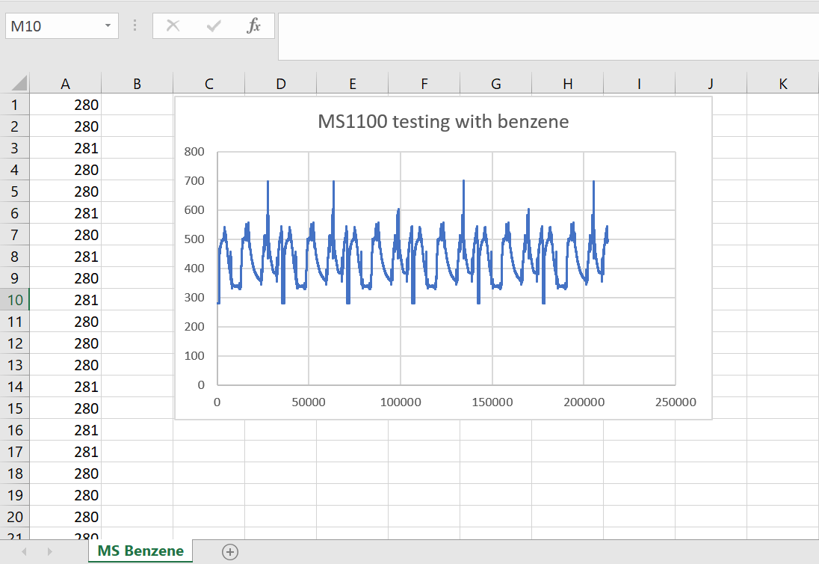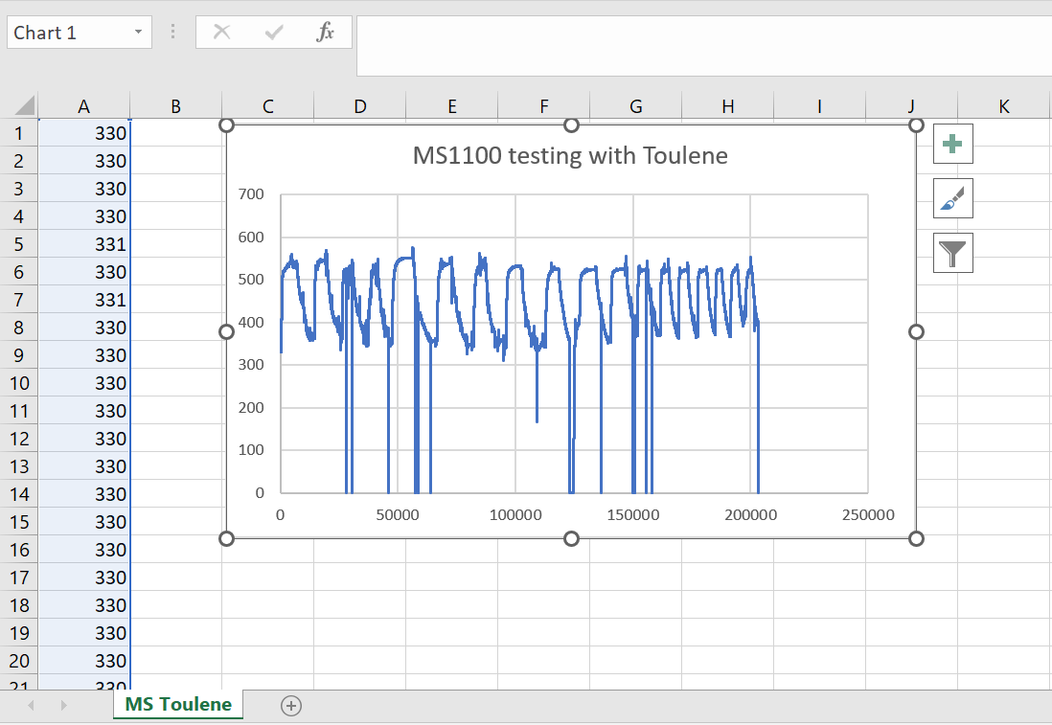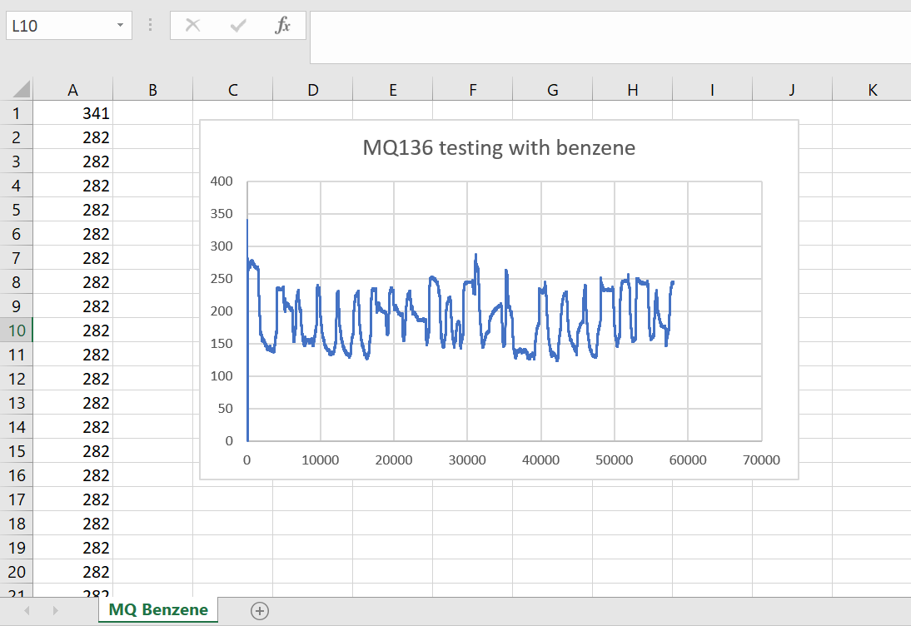

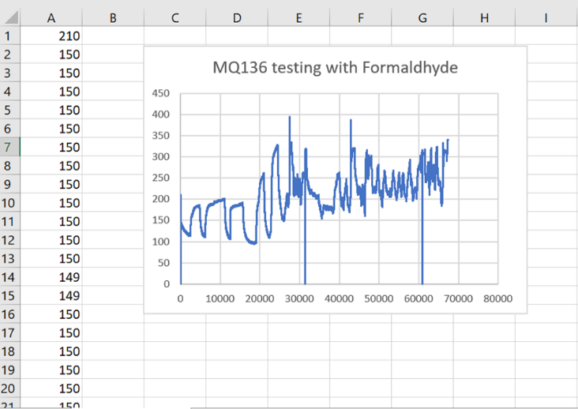

V. CONCLUSION

In conclusion, this proposed model stands as a pivotal advancement in ensuring human safety. The integration of diverse sensors, including ZMOD4510AI1R, SCD40-D-R1, MQ136, MS-1100, and CO Sensor Module ZE07-CO, lays the foundation for a comprehensive and versatile detection system. The utilization of both Raspberry Pi and Arduino for simultaneous data acquisition demonstrates the project's commitment to efficiency and real-time monitoring. This dual-platform integration ensures a robust and synchronized data collection process, enhancing the capabilities of the sensor array system. The sensor array system has been successfully employed for the detection of volatile organic compounds in a closed environment. The amalgamation of specialized sensors enables the system to identify a wide range of VOCs, contributing to environmental safety and well-being. The calibration of the sensor array for various concentrations of acetaldehyde, NO, and CO is a crucial accomplishment. This step ensures the accuracy and reliability of the sensors in detecting specific gases across different concentration levels. The calibrated system provides a foundation for precise and nuanced gas detection capabilities.

VI. REFERENCES

[1] A. Holovatyy, V. Teslyuk, M. Lobur, S. Pobereyko and Y. Sokolovsky, "Development of Arduino-Based Embedded System for Detection of Toxic Gases in Air," 2018 IEEE 13th International Scientific and Technical Conference on Computer Sciences and Information Technologies (CSIT), Lviv, Ukraine, 2018, pp. 139-142, doi: 10.1109/STC-CSIT.2018.8526672.

[2] M. Jualayba, K. Regio, H. Quiozon And A. Destreza, "Hazardous Gas Detection and Notification System," 2018 IEEE 10th International Conference on Humanoid, Nanotechnology, Information Technology,Communication and Control, Environment and Management (HNICEM), Baguio City, Philippines, 2018, pp. 1-4, doi: 10.1109/HNICEM.2018.8666358.

[3] G. A. García-Rodriguez et al., "Detection of volatile organic compounds using a commercial gas sensor embedded in a mobile robot," 2020 IEEE International Conference on Engineering Veracruz (ICEV), Boca del Rio, Mexico, 2020, pp. 1-4, doi: 10.1109/ICEV50249.2020.9289677.

[4] “Very volatile organic compounds: an understudied class of indoor air pollutants” by T. Salthammer

[5] [DatasheetZMOD4510AI1R](https://4donline.ihs.com/images/VipMasterIC/IC/RNCC/RNCC-S-A0011616774/RNCC-S-A0012988086-1.pdf?hkey=6D3A4C79FDBF58556ACFDE234799DDF0)

[6] [Datasheet of SCD40-D-R1](https://www.farnell.com/datasheets/3194661.pdf)

[7] [Datasheet of MQ136](http://www.datasheet.es/PDF/904646/MQ-136-pdf.html)

[8] [Datasheet of MS-1100](http://www.datasheet.es/PDF/904646/MQ-136-pdf.html)

[9] [Datasheet of ZE07-CO](https://www.winsensensor.com/d/files/PDF/Gas%20Sensor%20Module/CO%20Detection%20Module/ZE07%20CO%20Module%201.3V.pdf)